Fishery Data Series No. 04-31
Upper Cook Inlet Personal Use Salmon Fisheries, 1996-2003
by
Adam M. Reimer
and
Dora Sigurdsson
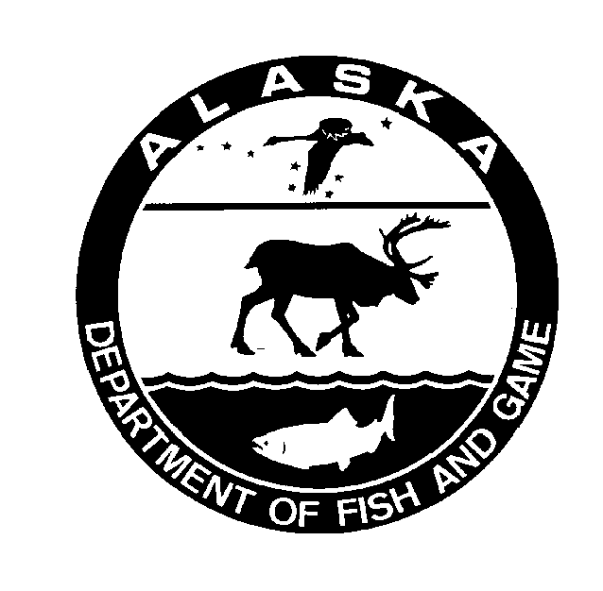
December 2004
Alaska Department of Fish and Game Divisions of Sport Fish and Commercial Fisheries
Symbols and Abbreviations
The following symbols and abbreviations, and others approved for the Système International d'Unités (SI), are used without definition in the following reports by the Divisions of Sport Fish and of Commercial Fisheries: Fishery Manuscripts, Fishery Data Series Reports, Fishery Management Reports, and Special Publications. All others, including deviations from definitions listed below, are noted in the text at first mention, as well as in the titles or footnotes of tables, and in figure or figure captions.

Weights and measures (metric)
centimeter cm
deciliter dL
gram g
hectare ha
kilogram kg
kilometer km
liter L
meter m
milliliter mL
millimeter mm

Weights and measures (English)
cubic feet per second ft³/s
foot ft
gallon gal
inch in
mile mi
nautical mile nmi
ounce oz
pound lb
quart qt
yard yd

Time and temperature
day d
degrees Celsius °C
degrees Fahrenheit °F
degrees kelvin K
hour h
minute min
second s

Physics and chemistry
all atomic symbols
alternating current AC
ampere A
calorie cal
direct current DC
hertz Hz
horsepower hp
hydrogen ion activity pH
(negative log of)
parts per million ppm
parts per thousand ppt,
‰
volts V
watts W
General
Alaska Administrative
Code AAC
all commonly accepted
abbreviations e.g., Mr., Mrs., AM, PM, etc.
all commonly accepted
professional titles e.g., Dr., Ph.D.,
R.N., etc.
at @
compass directions:
east E
north N
south S
west W
copyright ©
corporate suffixes:
Company Co.
Corporation Corp.
Incorporated Inc.
Limited Ltd.
District of Columbia D.C.
et alii (and others) et al.
et cetera (and so forth) etc.
exempli gratia
(for example) e.g.
Federal Information
Code FIC
id est (that is) i.e.
latitude or longitude lat. or long.
monetary symbols
(U.S.) $, ¢
months (tables and
figures): first three
letters Jan,...,Dec
registered trademark ®
trademark ™
United States
(adjective) U.S.
United States of
America (noun) USA
U.S.C. United States Code
U.S. state use two-letter abbreviations (e.g., AK, WA)
Measures (fisheries)
fork length FL
mideye-to-fork MEF
mideye-to-tail-fork METF
standard length SL
total length TL

Mathematics, statistics
all standard mathematical
signs, symbols and
abbreviations
alternate hypothesis H_{A}
base of natural logarithm e
catch per unit effort CPUE
coefficient of variation CV
common test statistics (F, t, χ², etc.)
confidence interval CI
correlation coefficient
(multiple) R
correlation coefficient
(simple) r
covariance cov
degree (angular ) °
degrees of freedom df
expected value E
greater than >
greater than or equal to ≥
harvest per unit effort HPUE
less than <
less than or equal to ≤
logarithm (natural) ln
logarithm (base 10) log
logarithm (specify base) log_{2,} etc.
minute (angular) '
not significant NS
null hypothesis H_{O}
percent %
probability P
probability of a type I error
(rejection of the null
hypothesis when true) α
probability of a type II error
(acceptance of the null
hypothesis when false) β
second (angular) "
standard deviation SD
standard error SE
variance
population Var
sample var

FISHERY DATA SERIES NO. 04-31
Upper Cook Inlet personal use salmon fisheries, 1996-2003
by
Adam M. Reimer
Division of Sport Fish, Soldotna
and

Alaska Department of Fish and Game
Division of Sport Fish, Research and Technical Services
333 Raspberry Road, Anchorage, Alaska, 99518-1599
December 2004

Dora Sigurdsson
Division of Sport Fish, Anchorage

The Division of Sport Fish Fishery Data Series was established in 1987 for the publication of technically oriented results for a single project or group of closely related projects. Since 2004, the Division of Commercial Fisheries has also used the Fishery Data Series. Fishery Data Series reports are intended for fishery and other technical professionals. Fishery Data Series reports are available through the Alaska State Library and on the Internet: http://www.sf.adfg.state.ak.us/statewide/divreports/html/intersearch.cfm This publication has undergone editorial and peer review.
Adam M. Reimer
Alaska Department of Fish and Game, Division of Sport Fish
43961 Kalifornsky Beach Road, Suite B, Soldotna, AK 99669-8367, USA
and
Dora Sigurdsson
Alaska Department of Fish and Game, Division of Sport Fish, Research and Technical Services
333 Raspberry Road, Anchorage, AK 99518-1599, USA

This document should be cited as:
Reimer, A. M, and D. Sigurdsson. 2004. Upper Cook Inlet personal use salmon fisheries, 1996-2003. Alaska Department of Fish and Game, Fishery Data Series No. 04-31, Anchorage.
The Alaska Department of Fish and Game administers all programs and activities free from discrimination based on race, color, national origin, age, sex, religion, marital status, pregnancy, parenthood, or disability. The department administers all programs and activities in compliance with Title VI of the Civil Rights Act of 1964, Section 504 of the Rehabilitation Act of 1973, Title II of the Americans with Disabilities Act of 1990, the Age Discrimination Act of 1975, and Title IX of the Education Amendments of 1972.
If you believe you have been discriminated against in any program, activity, or facility, or if you desire further information please write to ADF&G, P.O. Box 25526, Juneau, AK 99802-5526; U.S. Fish and Wildlife Service, 4040 N. Fairfield Drive, Suite 300, Arlington, VA 22203 or O.E.O., U.S. Department of the Interior, Washington DC 20240.
For information on alternative formats for this and other department publications, please contact the department ADA Coordinator at (voice) 907-465-4120, (TDD) 907-465-3646, or (FAX) 907-465-2440.
TABLE OF CONTENTS
Page
LIST OF TABLES ii
List OF FIGURES ii
List OF APPENDICES ii
ABSTRACT 1
INTRODUCTION 1
Management Plans 1
Fish Creek 1
Kasilof River 1
Kenai River 3
Fishing Regulations 3
Fish Creek Dip Net 3
Kasilof River Dip Net 3
Kasilof River Gillnet 3
Kenai River Dip Net 4
Objectives 4
METHODS 4
Study Design 4
Data Analysis 6
RESULTS 8
Permits Issued and Returned 8
Estimated Harvest and Effort 8
Fish Creek Dip Net 8
Kasilof River Dip Net 15
Kasilof River Gillnet 15
Kenai River Dip Net 17
Characteristics of Permit Holders 17
Residency of Permit Holders 17
Seasonal Variation 17
Household Size 17
Number of Days Fished/Fisheries Visited 22
DISCUSSION 22
Regulatory Compliance 25
ACKNOWLEDGEMENTS 25
references Cited 26
APPENDIX A. Example of a 2002 upper cook inlet personal use permit 27
APPENDIX B. Cumulative harvest timing for Upper Cook Inlet personal use fisheries, 1996-2003 31

LIST OF TABLES
Table Page
1. Number of Upper Cook Inlet personal use salmon fishery permits issued by year and number of permits returned by mailing and year, 1996-2003. 9
2. Number of Upper Cook Inlet personal use salmon fishery permits that did not fish by year, 1996-2003. 10
3. Effort and harvest in Upper Cook Inlet personal use salmon fisheries, 1996-2003. 12
4. Sockeye salmon exploitation rate by Upper Cook Inlet personal use fisheries, 1996-2003. 16
5. Residence areas for Upper Cook Inlet personal use salmon fishery permit holders by year, 1996-2003. 18
6. Summary of Upper Cook Inlet personal use permit holders by year, household size, number of days fished, and number of fisheries fished, 1996-2003. 20

List OF FIGURES
Figure Page
1. Maps of the areas open to personal use fishing. Fish Creek (Panel A), Kasilof River (Panel B), and Kenai River (Panel C). 2
2. Estimated Upper Cook Inlet personal use salmon harvest and corresponding 95% confidence intervals by fishery and mailing, 1997. 11
3. Percent of Upper Cook Inlet personal use salmon fishery permit holders from Anchorage, the Kenai Peninsula, the Matanuska-Susitna Valley and elsewhere by fishery and year. 19
4. Average percent of bag limit filled by fishery and year. 21
5. Percent of permits, percent of total harvest and average percent of bag limit filled by fishery and household size from 1996-2003. 23
6. Percent of permits, percent of total harvest and average percent of bag limit filled by fishery and number of days fished from 1996-2003. 24

List OF APPENDICES
Appendix Page
A1. Example of a 2002 Upper Cook Inlet personal use salmon permit. 28
B1. Cumulative harvest timing for the Fish Creek personal use dip net fishery 1996-2001. 32
B2. Cumulative harvest timing for the Kasilof personal use dip net fishery 1996-2003. 33
B3. Cumulative harvest timing for the Kasilof River personal use gillnet fishery 1996-2003. 34
B4. Cumulative harvest timing for the Kenai River personal use dip net fishery 1996-2003. 35

ABSTRACT
From 1996 to 2003 participants in the Upper Cook Inlet personal use salmon fisheries were required to record their harvest and effort on a free permit that was returned to the Alaska Department of Fish and Game after the fisheries closed. The number of personal use permits issued increased from 14,576 in 1996 to an estimated 19,110 (SE = 2) in 2003. The non-response rate increased during the same period. Returned permits were used to estimate harvest and effort for the Fish Creek dip net, Kasilof River dip net, Kasilof River gillnet and Kenai River dip net fisheries. Sockeye salmon harvest from 1996-2003 averaged 5,503 for Fish Creek dip net (1996-2001 only), 31,925 for Kasilof River dip net, 15,246 for Kasilof River gillnet and 140,428 for Kenai River dip net. Most permits were issued to residents of Anchorage followed by residents of the Kenai Peninsula and the Matanuska-Susitna Valley. Most permit holders did not fill their seasonal bag limit although differences in the percentage of the bag limit filled varied with respect to year, fishery, household size, number of days fished and the number of fisheries fished.
Key words: Kenai River, Kasilof River, Fish Creek, personal use, dip net, gillnet, subsistence, sockeye salmon, coho salmon, Chinook salmon, pink salmon, chum salmon, permit.

INTRODUCTION
Subsistence and personal use (PU) fishing in Cook Inlet has undergone numerous regulatory changes over the past two decades, reflecting the efforts by the state and federal governments and the court system to develop a legal definition of subsistence use (Brannian and Fox 1996). In 1996, most of Cook Inlet was closed to subsistence harvest of salmon. In lieu of subsistence fisheries four personal use fisheries were opened to all Alaska residents: Fish Creek dip net, Kasilof River dip net, Kasilof River gillnet, and Kenai River dip net (Figure 1). All of these fisheries target sockeye salmon Oncorhynchus nerka, although Chinook salmon O. tshawytscha, coho salmon O. kisutch, pink salmon O. gorbuscha and chum salmon O. keta are harvested incidentally. All participants in the Upper Cook Inlet salmon personal use fisheries are required to get a free permit or be a member of a household with a permit. Cook Inlet personal use permits are household permits that allow all members of the household to fish on the same permit. Completed permits must be returned to the department after the fishing season. This report presents harvest, effort and other summary information from Cook Inlet personal use permits issued during the 1996-2003 seasons.

Management Plans
All Upper Cook Inlet personal use salmon fisheries are managed under the provisions of the Upper Cook Inlet Personal Use Salmon Fishery Management Plan (5 AAC 77.540).

Fish Creek
Inseason management of this fishery is the responsibility of the Division of Sport Fish (SFD). SFD is also responsible for operation of a weir in Fish Creek. Prior to 2002, the fishery opened and closed by regulation, however frequent inseason management actions were required due to poor inriver returns. In 2002, the Alaska Board of Fisheries (BOF) changed the management plan so that the fishery would be open by emergency order only if the department projected that the escapement of sockeye salmon into Fish Creek will exceed 70,000 fish.

Kasilof River
Inseason management of the gillnet fishery is the responsibility of the Commercial Fisheries Division (CFD). CFD also operates a sonar counter on the Kasilof River. From 1996-2001 the gillnet fishery was opened and closed by emergency order based on a target harvest range. In
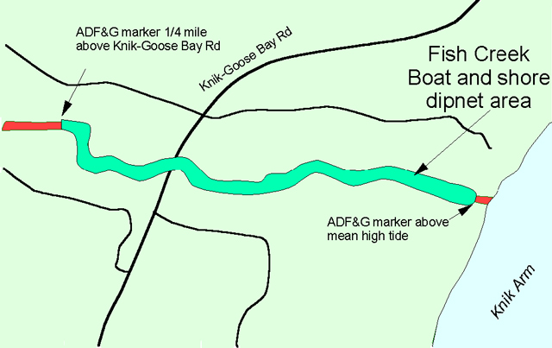
Panel A
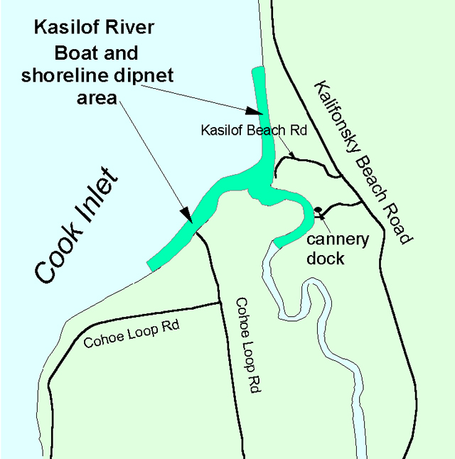
Panel B
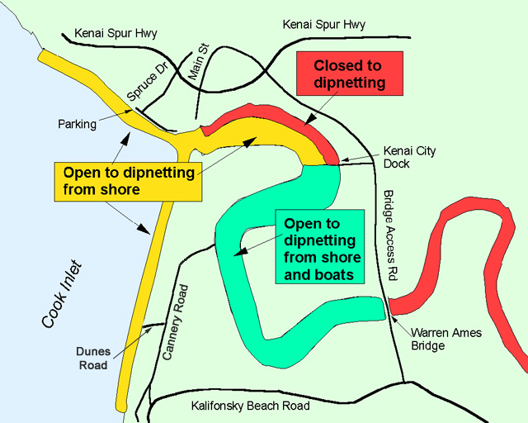
Panel C
Figure 1.-Maps of the areas open to personal use fishing. Fish Creek (Panel A), Kasilof River (Panel B), and Kenai River (Panel C).
2002, the BOF changed the management plan so that the gillnet fishery opens and closes by regulation, therefore inseason management is required only if the sonar count and biological escapement goal cannot be projected. Inseason management of the dip net fishery is the responsibility of SFD. The dip net fishery also opens and closes by regulation, and inseason management is only required if the sonar count and biological escapement goal cannot be projected.

Kenai River
Inseason management of this fishery is the responsibility of SFD, while the responsibility for operation of the Kenai River sonar counter is with CFD. The fishery opens and closes by regulation, and inseason management by SFD is only required if it is projected that the inriver escapement goal for sockeye salmon will not be met.

Fishing Regulations
Regulations for these fisheries are outlined in 5 AAC 77.015, 5 AAC 77.525 and 5 AAC 77.540. The fisheries are open to Alaska residents only. A legal dip net is a bag shaped net supported on all sides by a rigid frame. The net opening may not exceed 5 ft. across and the depth of the net must be at least one-half the net opening. The mesh used to construct the net may not exceed 4.5 inches stretched. Dip nets must be operated by hand. From 1996-2003 the total annual limit for all Upper Cook Inlet PU fisheries was 25 salmon for the head of the household and 10 salmon for each additional household member. From 1996-2001 there was an annual limit of one Chinook salmon combined from the Kenai River and Kasilof River dip net fisheries. No retention of Chinook salmon was allowed in the Fish Creek dip net fishery and there was no annual limit for Chinook salmon caught in the Kasilof River gillnet fishery. Beginning in 2002, no Chinook salmon could be retained in the Kasilof River dip net fishery, while the Kenai River annual limit remained at one Chinook salmon.

Fish Creek Dip Net
Dip netting was allowed in the area from Alaska Department of Fish and Game (ADF&G) regulatory markers located on both sides of the terminus of the creek upstream to ADF&G regulatory markers located approximately 1/4 mile upstream of the Knik-Goose Bay Road. Regulations for 1996-2001 allowed personal use dip netting from July 10 through July 31 from the hours of 1100-2300.
Beginning in 2002 regulations were modified so that the fishery would open only by emergency order. An emergency opening would be implemented if the department projected that the escapement of sockeye salmon into Fish Creek would exceed 70,000 fish. The fishery was not opened in 2002 or 2003.

Kasilof River Dip Net
Dip netting was allowed in the area from regulatory markers located on the Cook Inlet beaches outside of the terminus of the river upstream for one mile. The 1996-2001 regulations allowed dip netting from July 10 through August 5, 24 hours per day.
Beginning in 2002, the dip-netting season was expanded to begin on June 25 and end on August 7.

Kasilof River Gillnet
The legal fishing area was from ADF&G regulatory markers located at the river mouth to ADF&G commercial fishing regulatory markers located approximately one mile from the mouth in either direction. Additionally, fishing was prohibited more than one mile from the mean high tide mark and within any flowing waters of the Kasilof River at any tide stage. Only one set gillnet could be operated per permit. The gillnet had to be attended, by the permit holder or a person named on the permit, at all times it was being used to take fish. No set gillnet could be operated within 100 feet of another set gillnet. The gillnet could not exceed 10 fathoms in length, have larger than a six-inch mesh size, or be more than 45 meshes deep. Regulations for 1996-1998 allowed set gillnet fishing beginning on June 21 and continuing until closed by emergency order. Fishing was allowed from 0600 to 1800 each day that the fishery was open.
Regulations for 1999-2001 were changed so that set gillnet fishing was allowed beginning on June 16 until closed by emergency order.
Beginning in 2002 the fishery was open from June 15 through June 24, from 0600 to 2300, by regulation.

Kenai River Dip Net
Dip nets could only be used from shore in the area from ADF&G regulatory markers located on the Cook Inlet beaches outside of the terminus of the river upstream to the Warren Ames Bridge. Dipnetting from a boat was only allowed from ADF&G markers located near the Kenai City Dock upstream to the Warren Ames Bridge. The 1996 regulations allowed dip netting from July 10 through August 5, 24 hours per day.
Regulations for 1997 and 1998 were identical to 1996 except that the season was shortened to July 10 through July 31 to minimize the harvest of coho salmon.
Regulations for 1999-2001 were similar to previous years as well, except that the north shoreline was closed to dip netting from shore between an ADF&G marker located below Main Street in Kenai upstream to the Kenai City Dock. This regulation was implemented to minimize erosion to the bluffs below the city of Kenai.
Regulations for 2002 were further modified to allow dip netting only from 0600 to 2300 during the open season.

Objectives
From 1996-2003 the objectives of the study were to:
- Make permits available to all Alaskan residents that wished to participate in upper Cook Inlet personal use fisheries;
- Estimate participation (household days fished) and harvest for the Kasilof River gillnet, Kasilof River dip net, Kenai River dip net, and Fish Creek dip net fisheries such that the estimates were within 10% of true values 95% of the time for Kasilof River gillnet, Kasilof River dip net, and Kenai River dip net and within 20% of true values 95% of the time for the Fish Creek dip net fishery.

METHODS

Study Design
Cook Inlet personal use permits are household permits that allow all members of a household to fish on the same permit. All participants in the Upper Cook Inlet salmon personal use fisheries are required to get a permit or be a member of a household with a permit. In 1996 and 1997 permits were issued only from ADF&G offices. Beginning in 1998 permits were issued by more than 60 vendors and ADF&G offices located in Anchorage and the Kenai Peninsula and Matanuska-Susitna Valley areas. There was no cost for the permit.
Appendix A1 shows an example of the 2002 Upper Cook Inlet personal use salmon permit. Other years’ permits were similar in design and content. Each permit was divided into numbered halves. Permits were sequentially numbered and vendors were given known sequences. The top half was a vendor copy, which was retained by the vendor and contained the permit holder’s contact information, sport fishing license number and the angler’s signature. Vendor copies were returned to the Anchorage ADF&G office periodically throughout the summer using courtesy reply envelopes provided by the Division of Sport Fish. Data from the returned vendor copies were entered into an electronic database periodically throughout the summer.
The bottom half of each permit was a harvest card that was given to the permit holder. The permit holder was required to have this permit in their possession when personal use fishing. Permit holders were also required to record harvest information, including fishery, dates fished and salmon harvest by species immediately upon harvesting a fish. A check box was provided for households that did not fish. All permits, even for households that did not fish, were required to be returned to ADF&G by August 15.
Permit holders who did not return their permits received up to four reminder letters. Reminder letters were mailed to allow approximately four weeks to respond to the previous mailing. Data from returned permits were entered into an electronic database as they were received. In some cases returned permits reported that the household had harvested in excess of their seasonal bag limit, fished out of season, were not Alaskan residents, or some other regulatory violation. This information was entered into the database as it was recorded on the permit.
All permit-holders who returned their permits before the second reminder letter were treated as a census of “compliant” households. Information obtained by permit-holders who returned their permits after the second reminder letter was mailed were treated as a sample of “non-compliant” households. Participation and harvest by non-compliant households was estimated by calculating the mean participation (household days fished) and harvest by species for non-compliant permits that were returned and expanding to include all non-respondents. Total estimates of participation and harvest by species for each fishery were obtained by summing the estimates for the non-compliant households with the census information obtained from compliant households.
In 1996 and 1997 the number of permits issued was known because permits were only issued from ADF&G offices. Beginning in 1998, permits were issued from area vendors as well as from ADF&G offices. Occasionally vendors failed to return vendor copies from some of the permits they issued. This resulted in some permit holders returning permits that lacked a vendor copy. The total number of permits issued was estimated by assuming that the response rate (prior to mailing the first reminder letter) among known permits from a vendor was the same as the response rate among the permits lacking a vendor copy (the “orphan permits”). This response rate was applied to the orphan permits to estimate the total number of permits issued by the vendor but missing vendor copies.

Data Analysis
Because some vendors did not return all of their permits, the total number of permits issued was estimated as:
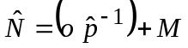 | (1)
where:
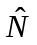 = | the total number of permits issued,
= | the number of permits issued and returned by permit holders before the first reminder letter, but with no vendor card (the “orphan permits”),
 = | 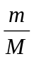= | the response rate before the first reminder letter among permits with vendor cards,
= | the number of permits returned before the first reminder letter mailing with vendor cards,
 = | the total number of permits with vendor cards.
With variance estimated as:
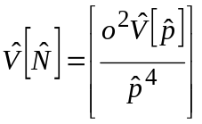 , | (2)
where,
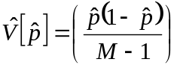 .
The estimated number of permits issued was divided in four groups:
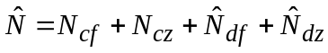 , | (3)
where:
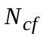= | the number of compliant permits who reported fishing,
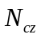= | the number of compliant permits who reported they did not fish,
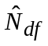= | 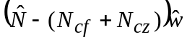,
 | the estimated number of non-compliant permits who reported fishing, and,
 | where 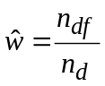
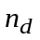 = the number of non-compliant households responding to the last reminder, and,
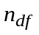 = the number of non-compliant households who responded to the last reminder and reported fishing.
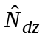= | the estimated number of non-compliant permits who reported they did not fish.

Harvest for each species or participation for each fishery was estimated by the following procedure (with subscripts denoting parameter of estimation deleted for simplicity):
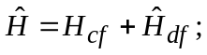 | (4)
where:
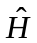 = | estimated total harvest or participation;
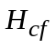 = | harvest or participation reported by compliant permits, and;
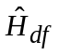 = | estimated harvest by non-compliant households = 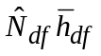
where 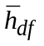 = the mean harvest or participation per household for non-compliant households that fished.
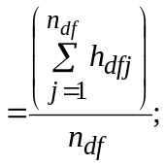
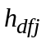 = | reported harvest by responding non-compliant household j, and
= | the number of non-compliant households responding to the reminder mailings.
Variance was calculated as (Goodman 1960):
, | (5)
where:
, | (6)
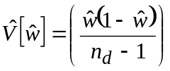,
and
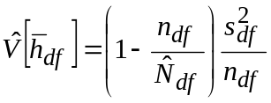 , | (7)
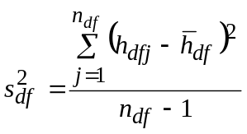 . | (8)
Standard errors were the square root of the variance estimate. Permittees who failed to indicate which fishery were estimated as “unknown fishery” by the procedure outlined above.
In 1996–1997 permits were only issued from ADF&G offices and the number of permits issued was known. From 1998–2000 the number of permits issued was estimated for each vendor following formulas 1 and 2 and then summed across vendors to get an estimate of the total number of permits issued. The non-compliant permits were not divided into those that reported not fishing and those that fished. Formulas 3-8 were used to estimate harvest and participation ignoring the second subscript.
In 1996-1997 permits were only issued from ADF&G offices and the number of permits issued was known.

RESULTS

Permits Issued and Returned
The number of permits issued for Upper Cook Inlet personal use fisheries has climbed from 14,576 in 1996 to an estimated 19,110 (SE = 2) in 2003 (Table 1). The percent of permits returned has decreased from 92% to 82% during the same period. An average of 32% of the households that were issued Upper Cook Inlet personal use permits did not fish (Table 2).
Since 1998, only two reminder mailings have been sent out annually. When four mailings were done in 1997, the harvest estimate stabilized after the second reminder letter (Figure 2). The increasing trend in the number of unreturned permits does not appear to be dependent on the reduced number of mailings in 1998-2002 (Table 1).

Estimated Harvest and Effort
From 1996-2003 over 1.64 million salmon (SE=2,316) were harvested in the Upper Cook Inlet personal use salmon fisheries (Table 3). Harvest in all fisheries during that period ranged from 151,113 (SE=604) salmon in 1997 to 305,245 (SE=1079) salmon in 2003. Most of the harvest was sockeye salmon although the annual harvest of coho and Chinook salmon reached seasonal maximums of 4,811 (SE=56) coho in 1996 and 1,711 (SE=34) Chinook in 2003. Effort in all fisheries averaged 18,761 household days with a range of 14,923 (SE=114) household days in 1997 to 21,668 (SE=63) household days in 2003.

Fish Creek Dip Net
Between 1996 and 2001, participation in the Fish Creek dip net fishery averaged 1,250 household days with a range of 131 (SE = 7) household days in 2001 to 3,749 (SE = 41) household days in 1996 (Table 3). Sockeye salmon harvest during the same period averaged 5,503 fish with a range of 436 (SE = 40) fish in 2001 to 17,260 (SE = 161) fish in 1996 (Table 3). Large numbers of coho salmon were also harvested in some years. The relative precision goals (± 20% of the true value 95% of the time) for effort and sockeye harvest were met each year except for sockeye harvest in 1999. Chinook salmon harvested in 1996 and 1998 were either violations of law (no retention of Chinook salmon was allowed) or incorrect reporting.
Sockeye salmon harvest in the Fish Creek personal use dip net fishery resulted in exploitation rates ranging from 1.0% of the inriver return in 2001 to 26.2% of the inriver return in 1996 (Table 4). The exploitation rate for the Fish Creek dip net fishery was highly variable because the inriver return fluctuated and management actions significantly altered the fishing season.
Table 1.–Number of Upper Cook Inlet personal use salmon fishery permits issued by year and number of permits returned by mailing and year, 1996-2003.
 |  | Permits Issued |  |  | Permits Returned |  |  |  |  |  |  |  |  |  |  |  |  |  |  |  |  |  | Permits not Returned
 |  |  |  |  | Voluntary |  |  | Mailing 1 |  |  | Mailing 2 |  |  | Mailing 3 |  |  | Mailing 4 |  |  | Total
Year |  | Numberª | SE |  | Number | % |  | Number | % |  | Number | % |  | Number | % |  | Number | % |  | Number | % |  | Number | %
1996 |  | 14,576 |  |  | 9,986 | 69 |  | 2,501 | 17 |  | 569 | 4 |  | 396 | 3 |  |  |  |  | 13,452 | 92 |  | 1,124 | 8
1997 |  | 14,919 |  |  | 7,031 | 47 |  | 4,792 | 32 |  | 1,148 | 8 |  | 506 | 3 |  | 279 | 2 |  | 13,756 | 92 |  | 1,163 | 8
1998 |  | 15,535 | 19 |  | 8,209 | 53 |  | 3,391 | 22 |  | 1,590 | 10 |  |  |  |  |  |  |  | 13,190 | 85 |  | 2,345 | 15
1999 |  | 17,197 | 25 |  | 8,960 | 52 |  | 3,771 | 22 |  | 1,485 | 9 |  |  |  |  |  |  |  | 14,216 | 83 |  | 2,981 | 17
2000 |  | 16,107 | 11 |  | 8,070 | 50 |  | 3,962 | 25 |  | 1,546 | 10 |  |  |  |  |  |  |  | 13,582 | 84 |  | 2,525 | 16
2001 |  | 16,915 | 1 |  | 8,515 | 50 |  | 3,896 | 23 |  | 1,987 | 12 |  |  |  |  |  |  |  | 14,398 | 85 |  | 2,517 | 15
2002 |  | 17,568 | 1 |  | 8,881 | 51 |  | 3,247 | 18 |  | 2,156 | 12 |  |  |  |  |  |  |  | 14,284 | 81 |  | 3,284 | 19
2003 |  | 19,110 | 2 |  | 9,602 | 50 |  | 3,587 | 19 |  | 2,537 | 13 |  |  |  |  |  |  |  | 15,726 | 82 |  | 3,384 | 18
Minimum |  | 14,576 |  |  | 7,031 | 47 |  | 2,501 | 17 |  | 569 | 4 |  | 396 | 3 |  | 279 | 2 |  | 13,190 | 81 |  | 1,124 | 8
Mean |  | 16,491 |  |  | 8,657 | 53 |  | 3,643 | 22 |  | 1,627 | 10 |  | 451 | 3 |  | 279 | 2 |  | 14,076 | 86 |  | 2,415 | 14
Maximum |  | 19,110 |  |  | 9,986 | 69 |  | 4,792 | 32 |  | 2,537 | 13 |  | 506 | 3 |  | 279 | 2 |  | 15,726 | 92 |  | 3,384 | 19
ª In 1996 and 1997 permits were only issued from ADF&G offices and the number of permits issued is known. The number of permits issued from 1998-2002 are estimates

Table 2.–Number of Upper Cook Inlet personal use salmon fishery permits that did not fish by year, 1996-2003.
 |  | Permits issued |  |  | Did not fish |  |  | % Did not fish
Year |  | Numberª | SE |  | Number^{b} | SE |  | Est. | SE
1996 |  | 14,576 |  |  | 4,408 |  |  | 30
1997 |  | 14,919 |  |  | 6,248 |  |  | 42
1998 |  | 15,535 | 19 |  | 5,539 |  |  | 36
1999 |  | 17,197 | 25 |  | 5,643 |  |  | 33
2000 |  | 16,107 | 11 |  | 5,745 |  |  | 36
2001 |  | 16,915 | 1 |  | 3,528 | 169 |  | 21 | 1
2002 |  | 17,568 | 1 |  | 4,858 | 176 |  | 28 | 1
2003 |  | 19,110 | 2 |  | 5,355 | 33 |  | 28 | 1
Minimum |  | 14,576 |  |  | 3,528 |  |  | 21
Mean |  | 16,491 |  |  | 5,166 |  |  | 32
Maximum |  | 19,110 |  |  | 6,248 |  |  | 42
ª In 1996 and 1997 permits were only issued from ADF&G offices and the number of permits issued is known. The number of permits issued from 1998-2002 are estimates.
^{b} Values for 1996-2000 represent the number of permits who reported not fishing. Values from 2001 and 2002 are the estimated number of permits that did not fish after expanding the number of permits who reported not fishing for non-respondents.

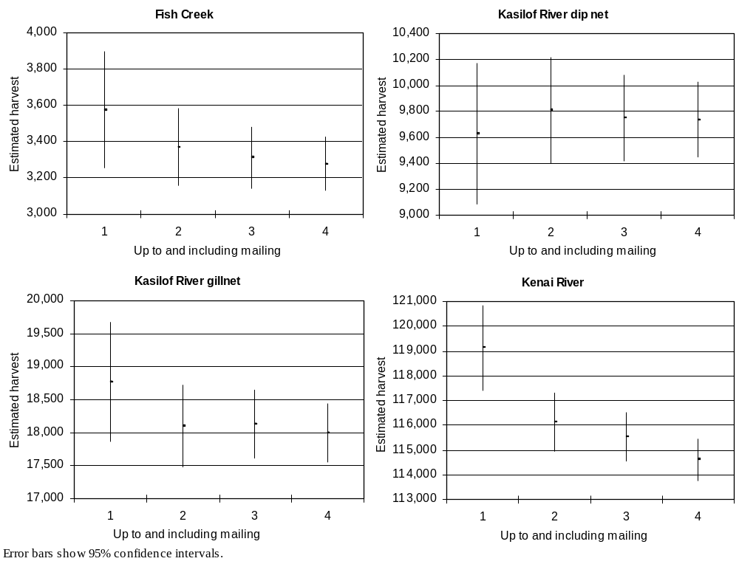
Figure 2.–Estimated Upper Cook Inlet personal use salmon harvest and corresponding 95% confidence intervals by fishery and mailing, 1997.
Table 3.–Effort and harvest in Upper Cook Inlet personal use salmon fisheries, 1996-2003.
 |  | Days Open | Days Fished |  |  |  | Sockeye |  |  |  | Chinook |  |  |  | Coho |  |  |  | Pink |  |  |  | Chum |  |  |  | Total
Year |  | Days Open | Est. | SE | RPª |  | Est. | SE | RPª |  | Est. | SE | RPª |  | Est. | SE | RPª |  | Est. | SE | RPª |  | Est. | SE | RPª |  | Est. | SE | RPª
Fish Creek Dip Net
1996 |  | 22 | 3,749 | 41 | 2% |  | 17,260 | 161 | 2% |  | 37 | 8 | 42% |  | 2,414 | 25 | 2% |  | 331 | 9 | 5% |  | 153 | 5 | 6% |  | 20,195 | 168 | 2%
1997 |  | 13 | 991 | 34 | 7% |  | 3,277 | 76 | 5% |  | 0 | 0 |  |  | 63 | 5 | 16% |  | 53 | 7 | 26% |  | 4 | 1 | 49% |  | 3,397 | 84 | 5%
1998 |  | 15 | 1,141 | 21 | 4% |  | 4,036 | 113 | 5% |  | 1 | 0 | 0% |  | 649 | 19 | 6% |  | 80 | 10 | 25% |  | 29 | 2 | 14% |  | 4,795 | 117 | 5%
1999 |  | 16 | 432 | 16 | 7% |  | 1,083 | 138 | 25% |  | 0 | 0 |  |  | 17 | 3 | 35% |  | 12 | 7 | 114% |  | 0 | 0 |  |  | 1,112 | 139 | 25%
2000 |  | 16 | 1,054 | 25 | 5% |  | 6,925 | 211 | 6% |  | 0 | 0 |  |  | 958 | 72 | 15% |  | 83 | 12 | 28% |  | 29 | 3 | 20% |  | 7,995 | 225 | 6%
2001 |  | 3 | 131 | 7 | 10% |  | 436 | 40 | 18% |  | 0 | 0 |  |  | 18 | 7 | 76% |  | 2 | 0 | 0% |  | 1 | 0 | 0% |  | 457 | 41 | 18%
2002 |  | 0
2003 |  | 0
Min. |  | 0 | 131 |  |  |  | 436 |  |  |  | 0 |  |  |  | 17 |  |  |  | 2 |  |  |  | 0 |  |  |  | 457
Mean |  | 11 | 1,250 |  |  |  | 5,503 |  |  |  | 6 |  |  |  | 687 |  |  |  | 94 |  |  |  | 36 |  |  |  | 6,325
Max. |  | 22 | 3,749 |  |  |  | 17,260 |  |  |  | 37 |  |  |  | 2,414 |  |  |  | 331 |  |  |  | 153 |  |  |  | 20,195
Kasilof River Dip Net
1996 |  | 27 | 1,300 | 23 | 3% |  | 11,197 | 127 | 2% |  | 50 | 1 | 4% |  | 334 | 18 | 11% |  | 103 | 2 | 4% |  | 17 | 0 | 0% |  | 11,701 | 130 | 2%
1997 |  | 27 | 1,091 | 32 | 6% |  | 9,737 | 150 | 3% |  | 35 | 2 | 11% |  | 90 | 3 | 7% |  | 19 | 2 | 21% |  | 19 | 1 | 10% |  | 9,900 | 153 | 3%
1998 |  | 27 | 3,421 | 33 | 2% |  | 45,161 | 525 | 2% |  | 134 | 3 | 4% |  | 731 | 18 | 5% |  | 610 | 25 | 8% |  | 74 | 32 | 85% |  | 46,710 | 528 | 2%
1999 |  | 27 | 3,611 | 43 | 2% |  | 37,176 | 507 | 3% |  | 127 | 5 | 8% |  | 286 | 50 | 34% |  | 264 | 12 | 9% |  | 52 | 8 | 30% |  | 37,905 | 511 | 3%
2000 |  | 27 | 2,622 | 36 | 3% |  | 23,877 | 403 | 3% |  | 134 | 7 | 10% |  | 1,004 | 16 | 3% |  | 841 | 39 | 9% |  | 34 | 0 | 0% |  | 25,890 | 407 | 3%
2001 |  | 27 | 3,382 | 37 | 2% |  | 37,612 | 505 | 3% |  | 138 | 6 | 9% |  | 766 | 25 | 6% |  | 307 | 14 | 9% |  | 23 | 0 | 0% |  | 38,846 | 511 | 3%
2002 |  | 44 | 4,020 | 38 | 2% |  | 46,769 | 530 | 2% |  | 106 | 6 | 11% |  | 1197 | 59 | 10% |  | 1862 | 73 | 8% |  | 139 | 7 | 10% |  | 50,073 | 553 | 2%
2003 |  | 44 | 3,874 | 28 | 1% |  | 43,870 | 440 | 2% |  | 57 | 4 | 14% |  | 592 | 49 | 16% |  | 286 | 21 | 14% |  | 30 | 1 | 7% |  | 44,835 | 447 | 2%
Min. |  | 27 | 1,091 |  |  |  | 9,737 |  |  |  | 35 |  |  |  | 90 |  |  |  | 19 |  |  |  | 17 |  |  |  | 9,900
Mean |  | 31 | 2,915 |  |  |  | 31,925 |  |  |  | 98 |  |  |  | 625 |  |  |  | 537 |  |  |  | 49 |  |  |  | 33,233
Max. |  | 44 | 4,020 |  |  |  | 46,769 |  |  |  | 138 |  |  |  | 1,197 |  |  |  | 1,862 |  |  |  | 139 |  |  |  | 50,073
-continued-

Table 3.–Page 2 of 3.
 |  | Days Open | Days Fished |  |  |  | Sockeye |  |  |  | Chinook |  |  |  | Coho |  |  |  | Pink |  |  |  | Chum |  |  |  | Total
Year |  | Days Open | Est. | SE | RPª |  | Est. | SE | RPª |  | Est. | SE | RPª |  | Est. | SE | RPª |  | Est. | SE | RPª |  | Est. | SE | RPª |  | Est. | SE | RPª
Kasilof River Gillnet
1996 |  | 5 | 582 | 16 | 5% |  | 9,506 | 156 | 3% |  | 46 | 3 | 13% |  | 0 | 0 |  |  | 8 | 0 | 0% |  | 1 | 0 | 0% |  | 9,561 | 157 | 3%
1997 |  | 5 | 815 | 26 | 6% |  | 17,997 | 231 | 3% |  | 65 | 2 | 6% |  | 1 | 0 | 0% |  | 102 | 7 | 13% |  | 3 | 1 | 65% |  | 18,168 | 233 | 3%
1998 |  | 5 | 1,075 | 24 | 4% |  | 15,975 | 425 | 5% |  | 126 | 7 | 11% |  | 0 | 0 |  |  | 15 | 4 | 52% |  | 12 | 10 | 163% |  | 16,128 | 426 | 5%
1999 |  | 10 | 1,287 | 39 | 6% |  | 12,832 | 371 | 6% |  | 442 | 27 | 12% |  | 25 | 2 | 16% |  | 10 | 0 | 0% |  | 10 | 0 | 0% |  | 13,319 | 374 | 6%
2000 |  | 13 | 1,252 | 23 | 4% |  | 14,774 | 275 | 4% |  | 514 | 15 | 6% |  | 9 | 0 | 0% |  | 17 | 2 | 23% |  | 10 | 0 | 0% |  | 15,324 | 276 | 4%
2001 |  | 8 | 1,001 | 20 | 4% |  | 17,201 | 394 | 4% |  | 174 | 6 | 7% |  | 6 | 0 | 0% |  | 11 | 0 | 0% |  | 7 | 5 | 140% |  | 17,399 | 397 | 4%
2002 |  | 10 | 1,025 | 16 | 3% |  | 17,980 | 274 | 3% |  | 192 | 5 | 5% |  | 12 | 0 | 0% |  | 30 | 2 | 13% |  | 13 | 4 | 60% |  | 18,227 | 277 | 3%
2003 |  | 10 | 1,206 | 17 | 3% |  | 15,706 | 277 | 3% |  | 400 | 13 | 6% |  | 107 | 0 | 0% |  | 9 | 0 | 0% |  | 4 | 0 | 0% |  | 16,226 | 284 | 3%
Min. |  | 5 | 582 |  |  |  | 9,506 |  |  |  | 46 |  |  |  | 0 |  |  |  | 8 |  |  |  | 1 |  |  |  | 9,561
Mean |  | 8 | 1,030 |  |  |  | 15,246 |  |  |  | 245 |  |  |  | 20 |  |  |  | 25 |  |  |  | 8 |  |  |  | 15,544
Max. |  | 13 | 1,287 |  |  |  | 17,997 |  |  |  | 514 |  |  |  | 107 |  |  |  | 102 |  |  |  | 13 |  |  |  | 18,227
Kenai River Dip Net
1996 |  | 27 | 10,503 | 60 | 1% |  | 102,821 | 367 | 1% |  | 295 | 5 | 3% |  | 1,932 | 29 | 3% |  | 2,404 | 33 | 3% |  | 175 | 10 | 11% |  | 107,627 | 375 | 1%
1997 |  | 22 | 11,023 | 87 | 2% |  | 114,619 | 439 | 1% |  | 364 | 13 | 7% |  | 559 | 21 | 7% |  | 619 | 14 | 4% |  | 58 | 5 | 17% |  | 116,219 | 448 | 1%
1998 |  | 18 | 10,802 | 59 | 1% |  | 103,847 | 716 | 1% |  | 254 | 10 | 8% |  | 1,011 | 62 | 12% |  | 1,032 | 62 | 12% |  | 85 | 3 | 7% |  | 106,229 | 724 | 1%
1999 |  | 22 | 13,738 | 79 | 1% |  | 149,504 | 1,084 | 1% |  | 488 | 13 | 5% |  | 1,009 | 108 | 21% |  | 1,666 | 64 | 8% |  | 102 | 13 | 25% |  | 152,769 | 1,094 | 1%
2000 |  | 22 | 12,354 | 69 | 1% |  | 98,262 | 752 | 1% |  | 410 | 18 | 9% |  | 1,449 | 62 | 8% |  | 1,457 | 75 | 10% |  | 193 | 31 | 31% |  | 101,771 | 762 | 1%
2001 |  | 22 | 14,772 | 66 | 1% |  | 150,766 | 909 | 1% |  | 638 | 15 | 5% |  | 1,555 | 105 | 13% |  | 1,326 | 37 | 5% |  | 155 | 19 | 24% |  | 154,440 | 926 | 1%
2002 |  | 22 | 14,840 | 56 | 1% |  | 180,028 | 844 | 1% |  | 606 | 11 | 4% |  | 1,721 | 64 | 7% |  | 5,662 | 102 | 4% |  | 551 | 36 | 13% |  | 188,568 | 874 | 1%
2003 |  | 22 | 15,263 | 50 | 1% |  | 223,580 | 891 | 1% |  | 1016 | 18 | 3% |  | 1,332 | 68 | 10% |  | 1,647 | 98 | 12% |  | 249 | 22 | 17% |  | 227,824 | 905 | 1%
Min. |  | 18 | 10,503 |  |  |  | 98,262 |  |  |  | 254 |  |  |  | 559 |  |  |  | 619 |  |  |  | 58 |  |  |  | 101,771
Mean |  | 22 | 12,912 |  |  |  | 140,428 |  |  |  | 509 |  |  |  | 1,321 |  |  |  | 1,977 |  |  |  | 196 |  |  |  | 144,431
Max. |  | 27 | 15,263 |  |  |  | 223,580 |  |  |  | 1,016 |  |  |  | 1,932 |  |  |  | 5,665 |  |  |  | 551 |  |  |  | 227,824
-continued-

Table 3.–Page 3 of 3.
 |  | Days Open | Days Fished |  |  |  | Sockeye |  |  |  | Chinook |  |  |  | Coho |  |  |  | Pink |  |  |  | Chum |  |  |  | Total
Year |  | Days Open | Est. | SE | RPª |  | Est. | SE | RPª |  | Est. | SE | RPª |  | Est. | SE | RPª |  | Est. | SE | RPª |  | Est. | SE | RPª |  | Est. | SE | RPª
Unknown Fishery
1996 |  |  | 472 | 33 |  |  | 4,761 | 463 |  |  | 24 | 7 |  |  | 131 | 37 |  |  | 127 | 37 |  |  | 4 | 3 |  |  | 5,047 | 467
1997 |  |  | 1,003 | 50 |  |  | 3,310 | 276 |  |  | 0 | 0 |  |  | 64 | 14 |  |  | 51 | 21 |  |  | 4 | 3 |  |  | 3,429 | 282
1998 |  |  | 921 | 39 |  |  | 7,562 | 287 |  |  | 34 | 5 |  |  | 294 | 77 |  |  | 196 | 19 |  |  | 20 | 0 |  |  | 8,106 | 301
1999 |  |  | 684 | 20 |  |  | 7,994 | 352 |  |  | 51 | 5 |  |  | 76 | 7 |  |  | 126 | 2 |  |  | 4 | 0 |  |  | 8,251 | 353
2000 |  |  | 648 | 23 |  |  | 5,429 | 274 |  |  | 44 | 13 |  |  | 218 | 60 |  |  | 84 | 11 |  |  | 24 | 15 |  |  | 5,799 | 282
2001 |  |  | 1,339 | 34 |  |  | 12,673 | 380 |  |  | 188 | 17 |  |  | 292 | 30 |  |  | 175 | 24 |  |  | 90 | 34 |  |  | 13,418 | 394
2002 |  |  | 1,339 | 26 |  |  | 14,846 | 353 |  |  | 166 | 10 |  |  | 341 | 25 |  |  | 916 | 81 |  |  | 54 | 8 |  |  | 16,323 | 380
2003 |  |  | 1,325 | 21 |  |  | 15,675 | 247 |  |  | 238 | 25 |  |  | 219 | 14 |  |  | 140 | 9 |  |  | 88 | 9 |  |  | 16,360 | 254
Min. |  |  | 472 |  |  |  | 3,310 |  |  |  | 0 |  |  |  | 64 |  |  |  | 51 |  |  |  | 4 |  |  |  | 3,429
Mean |  |  | 966 |  |  |  | 9,031 |  |  |  | 93 |  |  |  | 204 |  |  |  | 227 |  |  |  | 36 |  |  |  | 9,592
Max. |  |  | 1,339 |  |  |  | 15,675 |  |  |  | 238 |  |  |  | 341 |  |  |  | 916 |  |  |  | 90 |  |  |  | 16,360
Upper Cook Inlet Personal Use Fisheries Total
1996 |  |  | 16,606 | 85 |  |  | 145,545 | 644 |  |  | 452 | 12 |  |  | 4,811 | 56 |  |  | 2,973 | 50 |  |  | 350 | 12 |  |  | 154,131 | 655
1997 |  |  | 14,923 | 114 |  |  | 148,940 | 592 |  |  | 464 | 13 |  |  | 777 | 26 |  |  | 844 | 27 |  |  | 88 | 6 |  |  | 151,113 | 604
1998 |  |  | 17,360 | 84 |  |  | 176,581 | 1,032 |  |  | 549 | 14 |  |  | 2,685 | 102 |  |  | 1,933 | 70 |  |  | 220 | 34 |  |  | 181,968 | 1,043
1999 |  |  | 19,752 | 101 |  |  | 208,589 | 1,309 |  |  | 1,108 | 31 |  |  | 1,413 | 119 |  |  | 2,078 | 66 |  |  | 168 | 15 |  |  | 213,356 | 1,320
2000 |  |  | 17,930 | 88 |  |  | 149,267 | 961 |  |  | 1,102 | 28 |  |  | 3,638 | 114 |  |  | 2,482 | 86 |  |  | 290 | 35 |  |  | 156,779 | 976
2001 |  |  | 20,625 | 86 |  |  | 218,688 | 1,176 |  |  | 1,138 | 24 |  |  | 2,637 | 112 |  |  | 1,821 | 46 |  |  | 276 | 39 |  |  | 224,560 | 1,197
2002 |  |  | 21,224 | 74 |  |  | 259,623 | 1,092 |  |  | 1,070 | 17 |  |  | 3,271 | 91 |  |  | 8,470 | 149 |  |  | 757 | 38 |  |  | 273,191 | 1,136
2003 |  |  | 21,668 | 63 |  |  | 298,831 | 1,061 |  |  | 1,711 | 34 |  |  | 2,250 | 85 |  |  | 2,082 | 101 |  |  | 371 | 24 |  |  | 305,245 | 1,079
Min. |  |  | 14,923 |  |  |  | 145,545 |  |  |  | 452 |  |  |  | 777 |  |  |  | 844 |  |  |  | 88 |  |  |  | 151,113
Mean |  |  | 18,761 |  |  |  | 200,758 |  |  |  | 949 |  |  |  | 2,685 |  |  |  | 2,835 |  |  |  | 315 |  |  |  | 207,543
Max. |  |  | 21,668 |  |  |  | 298,831 |  |  |  | 1,711 |  |  |  | 4,811 |  |  |  | 8,470 |  |  |  | 757 |  |  |  | 305,245
ª Relative precision

The median date for sockeye salmon harvest was approximately July 21 (Appendix B1). The fishery usually closed a few days later meaning daily harvest was much greater after the median date than it was prior. As expected coho salmon harvest occurred mostly in the last few days of the season. Harvest timing for the Fish Creek dip net fishery may be of limited value because the fishing season, effort and harvest have varied so markedly.

Kasilof River Dip Net
Between 1996 and 2003, participation in the Kasilof River dip net fishery averaged 2,915 household days with a range of 1,091 (SE = 32) household days in 1997 to 4,020 (SE = 38) household days in 2002 (Table 3). Sockeye salmon harvest during the same period averaged 31,925 fish with a range of 9,737 (SE = 150) fish in 1997 to 46,769 (SE = 530) fish in 2002 (Table 3). Harvests of other species were relatively small. The relative precision goals (± 10% of the true value 95% of the time) for effort and sockeye salmon harvest were met each year. Since the fishery was closed to Chinook salmon harvest in 2002 and 2003 and Chinook salmon harvests are similar in magnitude to prior years they are likely violations of law.
Sockeye salmon harvest in the Kasilof River personal use dip net fishery resulted in exploitation rates ranging from 3.3% of the inriver return in 1997 to 15.9% of the inriver return in 2002 (Table 4). The exploitation rate for the Kasilof River dip net fishery stabilized at about 10% of the inriver return from 1998-2001. Extending the fishing season from 27 days to 44 days led to the largest recorded exploitation rate (15.9%) in 2002, but the exploitation rate was again near 10% in 2003.
The median date for Kasilof River personal use sockeye salmon harvest was about July 22 (Appendix B2), or approximately half way through the open season. The lengthened fishing seasons in 2002 and 2003 shifted the median harvest dates about five days earlier. Harvest timing for Chinook salmon was similar to sockeye salmon. Most coho salmon harvest occurred toward the end of the season.

Kasilof River Gillnet
Between 1996 and 2003, participation in the Kasilof River gillnet fishery averaged 1,030 household days with a range of 582 (SE = 16) household days in 1996 to 1,287 (SE = 39) household days in 2002 (Table 3). Sockeye salmon harvest during the same period averaged 15,246 fish with a range of 9,506 (SE = 156) fish in 1996 to 17,997 (SE = 231) fish in 1997 (Table 3). Chinook salmon harvests during the same period averaged 245 fish with a range of 46 (SE = 3) fish in 1996 to 514 (SE = 15) fish in 2000 (Table 3). The relative precision goals (± 10% of the true value 95% of the time) for effort and sockeye harvest were met each year.
Sockeye salmon harvest in the Kasilof River personal use gillnet fishery resulted in exploitation rates ranging from 3.5% of the inriver return in 1996 to 6.1% of the inriver return in 1997 and 2002 (Table 4). When combined with the exploitation rate for the Kasilof River dip net fishery the total sockeye salmon exploitation rate from personal use fisheries for the Kasilof River averaged 14.1% from 1996-2003 and ranged from 7.6% in 1996 to 22.0% in 2002.
Harvest timing for the Kasilof River gillnet fishery was heavily dependent on season opening date because the fishery has a very short season. The median harvest date for sockeye salmon was June 19 in both 2002 and 2003, and the median harvest date for Chinook salmon was June 17 in both 2002 and 2003 (Appendix B3).

Table 4.–Sockeye salmon exploitation rate by Upper Cook Inlet personal use fisheries, 1996-2003.
 |  | Harvest |  |  | Inriver |  |  | Exploitation Rate
Year |  | Dip net | Gillnet |  | Return | ^{a,b,c} |  | Dip net | Gillnet | Combined
Fish Creek
1996 |  | 17,260 |  |  | 80,488 |  |  | 21.4%
1997 |  | 3,277 |  |  | 58,434 |  |  | 5.6%
1998 |  | 4,036 |  |  | 27,055 |  |  | 14.9%
1999 |  | 1,083 |  |  | 28,261 |  |  | 3.8%
2000 |  | 6,925 |  |  | 26,479 |  |  | 26.2%
2001 |  | 436 |  |  | 43,932 |  |  | 1.0%
2002 |  | -fishery closed-
2003 |  | -fishery closed-
Minimum |  | 436 |  |  | 26,479 |  |  | 1.0%
Mean |  | 5,503 |  |  | 44,108 |  |  | 12.2%
Maximum |  | 17,260 |  |  | 80,488 |  |  | 26.2%
Kasilof River
1996 |  | 11,197 | 9,506 |  | 272,524 |  |  | 4.1% | 3.5% | 7.6%
1997 |  | 9,737 | 17,997 |  | 296,855 |  |  | 3.3% | 6.1% | 9.3%
1998 |  | 45,161 | 15,975 |  | 336,936 |  |  | 13.4% | 4.7% | 18.1%
1999 |  | 37,176 | 12,832 |  | 366,086 |  |  | 10.2% | 3.5% | 13.7%
2000 |  | 23,877 | 14,774 |  | 298,903 |  |  | 8.0% | 4.9% | 12.9%
2001 |  | 37,612 | 17,201 |  | 366,887 |  |  | 10.3% | 4.7% | 14.9%
2002 |  | 46,769 | 17,980 |  | 294,749 |  |  | 15.9% | 6.1% | 22.0%
2003 |  | 43,870 | 15,706 |  | 424,609 |  |  | 10.3% | 3.7% | 14.0%
Minimum |  | 9,737 | 9,506 |  | 272,524 |  |  | 3.3% | 3.5% | 7.6%
Mean |  | 31,925 | 15,246 |  | 332,194 |  |  | 9.4% | 4.7% | 14.1%
Maximum |  | 46,769 | 17,997 |  | 424,609 |  |  | 15.9% | 6.1% | 22.0%
Kenai River
1996 |  | 102,821 |  |  | 941,678 |  |  | 10.9%
1997 |  | 114,619 |  |  | 1,224,470 |  |  | 9.4%
1998 |  | 103,847 |  |  | 906,959 |  |  | 11.5%
1999 |  | 149,504 |  |  | 1,000,312 |  |  | 14.9%
2000 |  | 98,262 |  |  | 781,997 |  |  | 12.6%
2001 |  | 150,766 |  |  | 853,874 |  |  | 17.7%
2002 |  | 180,028 |  |  | 1,186,742 |  |  | 15.2%
2003 |  | 223,580 |  |  | 1,473,516 |  |  | 15.2%
Minimum |  | 98,262 |  |  | 781,997 |  |  | 9.4%
Mean |  | 140,428 |  |  | 1,046,194 |  |  | 13.4%
Maximum |  | 223,580 |  |  | 1,473,516 |  |  | 17.7%
ª 1996-1991 estimates from Tobias and Willette (2003).
^{b} 2002-2003 estimates from Terri Tobias (personal communication).
^{c} Inriver return calculated as sonar or weir passage plus subsistence and/or personal use harvest plus sport harvest below sonar or weir.

Kenai River Dip Net
Between 1996 and 2003, participation in the Kenai River dip net fishery averaged 12,912 household days with a range of 10,503 (SE = 60) household days in 1996 to 15,263 (SE = 50) household days in 2003 (Table 3). Sockeye salmon harvest during the same period averaged 140,428 fish with a range of 98,262 (SE = 752) fish in 2000 to 223,580 (SE = 891) fish in 2003 (Table 3). Harvests of other species were comparatively small. The relative precision goals (± 10% of the true value 95% of the time) for effort and sockeye harvest were met each year.
Sockeye salmon harvest in the Kenai River personal use dip net fishery resulted in exploitation rates ranging from 9.4% to 17.7% of the inriver return (Table 4). The reduction in fishing time in 2002 and 2003, from 24 hours to 17 hours per day, had little effect on the exploitation rate or total harvest.
The median date for Kenai River personal use sockeye salmon harvest was about July 21 (Appendix B4), or approximately half way through the open season. Harvest timing for Chinook salmon was similar to sockeye salmon. Most coho salmon harvest occurred toward the end of the season.

Characteristics of Permit Holders

Residency of Permit Holders
Over 97% of all Upper Cook Inlet personal use permit holders resided in Southcentral Alaska (Region II) each year from 1996-2003 (Table 5). Of those who resided in Southcentral Alaska, the majority resided in Anchorage, followed by the Kenai Peninsula, and the Matanuska-Susitna Valley. The percentage of permit holders from Anchorage has increased from 52.0% in 1996 to 59.4% in 2003.
Residents of Anchorage were a substantial majority of the participants in the Kenai River and Kasilof River personal use dip net fisheries whereas residents of the Matanuska-Susitna Valley were the predominant participants in the Fish Creek personal use fishery, and residents of the Kenai Peninsula were the predominate participants in the Kasilof River personal use gillnet fishery (Figure 3). From 1996 to 2002 Anchorage residents became an increasing percentage of the participants in the Kenai River personal use fishery and a decreasing percentage of the participants in the Fish Creek personal use fishery. During the same period residents of the Matanuska-Susitna Valley became an increasing percentage of the participants in all of the Kenai Peninsula personal use fisheries.

Seasonal Variation
Participants in the Upper Cook Inlet personal use fisheries became more efficient during the period from 1996-2003. The average percentage of the bag limit harvested by Upper Cook Inlet permit holders increased from 35.3% (SE=0.3%) in 1996 to 50.6% (SE=0.3%) in 2003 (Table 6). Consideration of returned permits from households that only participated in only one fishery allow the degree of similarity between fisheries to be examined. Permit holders who participated in either Kasilof River fishery filled a larger percent of their bag limit than participants in the Fish Creek or Kenai River fisheries (Figure 4).

Household Size
Permits were most commonly issued to two and four-person households from 1996-2003 (Table 6). While some very large households did obtain permits, households of five people or less
Table 5.–Residence areas for Upper Cook Inlet personal use salmon fishery permit holders by year, 1996-2003.
 |  | SWHS |  | Year
Area of Residence |  | Areaª |  | 1996 | 1997 | 1998 | 1999 | 2000 | 2001 | 2002 | 2003
 | Regional breakdown^{b}
 | Region 1 | A-H |  | 0.2% | 0.2% | 0.3% | 0.1% | 0.2% | 0.2% | 0.1% | 0.2%
 | Region 2 | J-N,P-T |  | 98.5% | 98.6% | 98.1% | 98.3% | 98.5% | 98.1% | 97.7% | 97.4%
 | Region 3 | I,U-Z |  | 1.3% | 1.3% | 1.3% | 1.5% | 1.3% | 1.6% | 2.0% | 2.3%
 | Out of State/Unknown residence |  |  | 0.0% | 0.0% | 0.3% | 0.1% | 0.1% | 0.1% | 0.1% | 0.1%
 | SUM |  |  | 100% | 100% | 100% | 100% | 100% | 100% | 100% | 100%
 | Region 2 breakdown
 | Anchorage area | L |  | 52.0% | 53.9% | 54.2% | 55.4% | 57.0% | 58.6% | 58.2% | 59.4%
 | Kenai Penninsula area | P |  | 30.4% | 31.3% | 32.3% | 32.1% | 29.2% | 29.7% | 29.1% | 26.4%
 | Matanuska-Susitna Valley area | K |  | 14.8% | 12.4% | 10.5% | 9.5% | 11.3% | 8.6% | 9.2% | 10.1%
 | Other region 2 areas | J,M,N,Q-T |  | 1.3% | 1.0% | 1.1% | 1.3% | 1.0% | 1.2% | 1.2% | 1.6%
 | SUM |  |  | 98.5% | 98.6% | 98.1% | 98.3% | 98.5% | 98.1% | 97.7% | 97.4%
ª Statistical areas used in the Statewide Harvest Survey (Jennings et al. In prep).
^{b} Region 1 is Southeastern Alaska, Region 2 is Southcentral Alaska, and Region 3 is Interior Alaska.

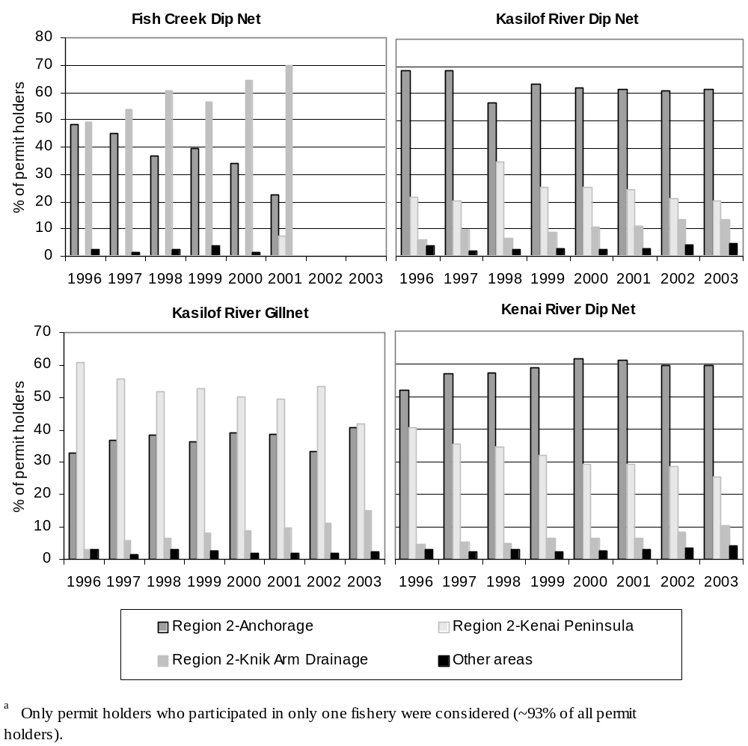
Figure 3.-Percent of Upper Cook Inlet personal use salmon fishery permit holders from Anchorage, the Kenai Peninsula, the Matanuska-Susitna Valley and elsewhere by fishery and yearª.

Table 6.–Summary of Upper Cook Inlet personal use permit holders by year, household size, number of days fished, and number of fisheries fished, 1996-2003.
 | % of  permits |  | % of total  harvest |  | Average % of  bag limit filled | SE (% of bag  limit filled)
Year
1996 | 11.0% |  | 11.1% |  | 35.3% | 0.3%
1997 | 11.3% |  | 10.0% |  | 39.2% | 0.4%
1998 | 11.8% |  | 11.6% |  | 43.2% | 0.4%
1999 | 13.0% |  | 13.2% |  | 44.2% | 0.4%
2000 | 12.2% |  | 12.0% |  | 36.0% | 0.4%
2001 | 12.8% |  | 13.8% |  | 43.7% | 0.3%
2002 | 13.3% |  | 13.7% |  | 48.9% | 0.3%
2003 | 14.5% |  | 14.5% |  | 50.6% | 0.3%
Total | 100.0% |  | 100.0%
Number of household members
1 | 13.5% |  | 8.7% |  | 49.8% | 0.4%
2 | 30.4% |  | 26.4% |  | 47.9% | 0.2%
3 | 16.7% |  | 16.1% |  | 41.4% | 0.3%
4 | 21.3% |  | 23.2% |  | 38.4% | 0.2%
5 | 10.8% |  | 13.6% |  | 37.6% | 0.3%
6 | 4.3% |  | 6.4% |  | 37.9% | 0.5%
7+ | 3.0% |  | 5.6% |  | 37.6% | 0.6%
Total | 100.0% |  | 100.0%
Number of days
1 | 55.5% |  | 40.5% |  | 33.1% | 0.2%
2 | 26.5% |  | 30.7% |  | 49.9% | 0.2%
3 | 11.0% |  | 16.3% |  | 61.2% | 0.3%
4 | 4.4% |  | 7.3% |  | 67.1% | 0.5%
5+ | 2.7% |  | 5.2% |  | 74.0% | 0.6%
Total | 100.0% |  | 100.0%
Number of fisheries fished ª
1 | 94.6% |  | 92.4% |  | 42.4% | 0.1%
2 | 5.3% |  | 7.4% |  | 56.9% | 0.5%
3 | 0.1% |  | 0.2% |  | 65.7% | 3.1%
Total | 100.0% |  | 100.0%
ª For all years combined

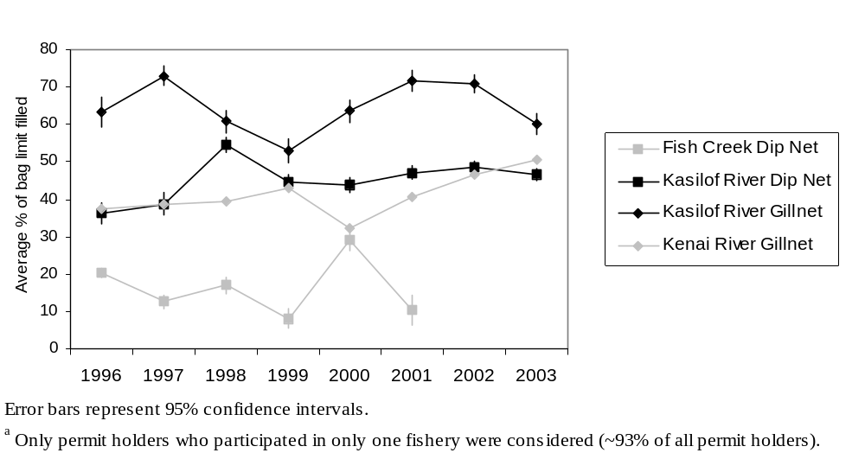
Figure 4.–Average percent of bag limit filled by fishery and yearª.
obtained 92.7% of the total permits issued from 1996-2003 (Table 6). Since the seasonal bag limit for Upper Cook Inlet personal use fisheries is based on household size, the average percent of the bag limit harvested by household size is presented in Table 6. The average percent of the bag limit harvested decreased from 49.8% (SE=0.4%) for one-person households to 37.6% (SE=0.6%) for households of seven or more from 1996-2003. These patterns persisted when each fishery (Figure 5) was analyzed separately although Fish Creek personal use households tended to consist of more large families. Households of all sizes were more successful in the Kasilof River fisheries (Figure 5). These patterns also persisted when each year was analyzed separately.

Number of Days Fished/Fisheries Visited
Many permit holders fished multiple days per season although 55.5% of permit holders fished only one day (Table 6). Those permit holders who did fish more than one day increased the average percentage of their bag limit harvested from 33.1% (SE=0.2%) for households that fished one day to 74.0% (SE=0.6%) for households that fished five or more days. These patterns persisted when each fishery was analyzed separately (Figure 6) although permit holders at Fish Creek experienced the largest benefit from fishing multiple days. These patterns also persisted when each year was analyzed separately.
Few Upper Cook Inlet personal use permit holders participated in more than one fishery from 1996 to 2003 (Table 6). Of those who participated in two fisheries over 90% fished the Kenai River along with another fishery (most often Kasilof River dip net). Of those who participated in three fisheries, combinations involving the Kenai River accounted for over 98%. Those permit holders who visited more than one fishery increased the average percentage of their bag limit filled from 42.1% (SE=0.1%) for households that visited one fishery to 65.7% (SE=3.1%) for households that visited three fisheries.

DISCUSSION
The 2003 season produced record levels of effort and harvest by Upper Cook Inlet personal use salmon fishery permit holders. These record levels were driven by record effort and harvest in the Kenai River personal use salmon fishery although both Kasilof River fisheries produced above average levels of effort and harvest in 2003. The 2002 season produced similar record or near record harvest and effort estimates.
There are several fishery related explanations for these increasing harvest and effort levels. First, Upper Cook Inlet personal use fishing increased in popularity from 1996-2003 as shown by the increased number of permits issued (Table 1). The percentage of permit holders who were issued permits but did not fish did not increase during the same period (Table 2). Second, personal use permit holders harvested an increasing percentage of their bag limit each year (Table 6).
Recent liberalizations to the Kasilof River dip net fishery did have the intended effect of increasing effort and harvest in that fishery. For example, regulatory changes extended the 2002 and 2003 Kasilof River dip net fishery season 15 days earlier and 2 days later than the 1996-2001 seasons. The lengthened season led to the largest sockeye, coho, and pink salmon harvests on record (Table 3) as well as the largest sockeye salmon exploitation rate on record (Table 4) in 2002. The 2003 season did not produce record levels in any of these areas but did produce harvest and effort estimates which were well above average.
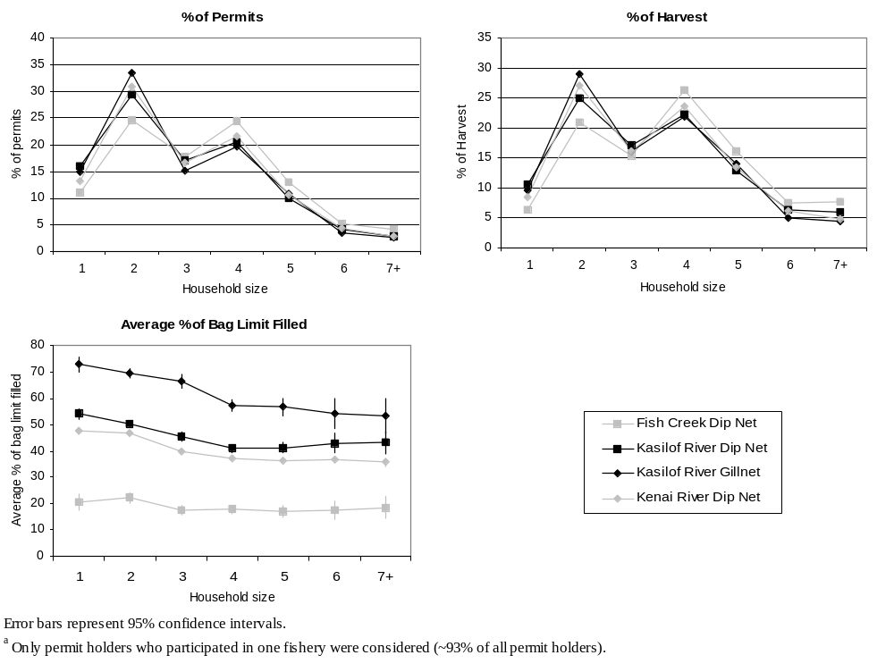
Figure 5.–Percent of permits, percent of total harvest and average percent of bag limit filled by fishery and household sizeª from 1996-2003.
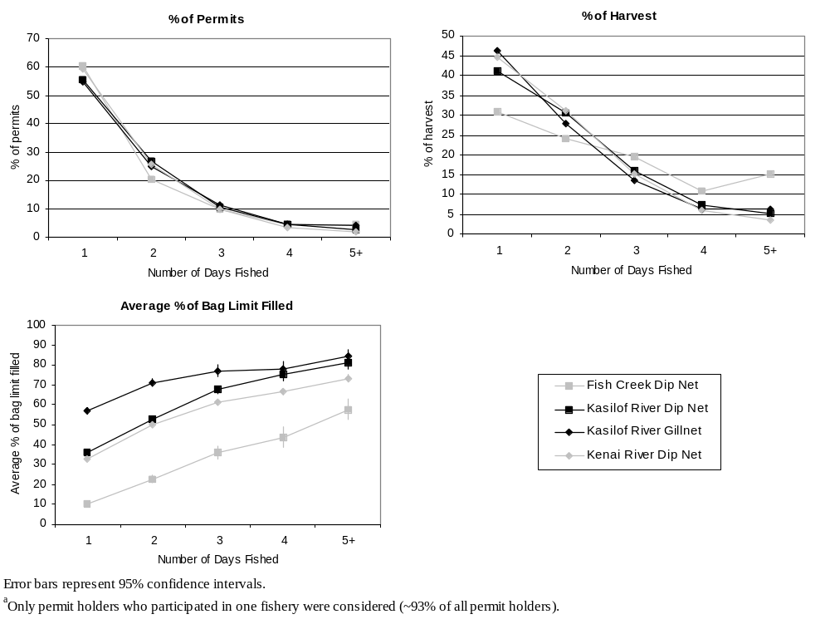
Figure 6.–Percent of permits, percent of total harvest and average percent of bag limit filled by fishery and number of days fished from 1996-2003ª.
Conversely, recent regulatory restrictions to the Kenai River personal use dip net fishery did not have the intended effect of reducing effort, harvest and exploitation rates in the fishery. Beginning in 2002, personal use dipnetting was restricted to 17 hours per day (0600 to 2300).
This regulatory change had no effect on harvest, participation, or exploitation rate. In fact, effort and sockeye salmon harvest were the highest recorded in 2002 (Table 3). In 2003, record effort and sockeye salmon harvest levels were achieved again although the fishery was liberalized to allow personal use fishing 24 hours per day starting July 19th.
Analysis of Upper Cook Inlet personal use fisheries indicates that the bag limit exceeds most permit holders’ actual harvest. In addition, the current bag limit increases at a faster rate than larger households increase their harvest. Households with the time and/or inclination to make more than one trip or visit more than one fishery successfully filled a larger percentage of their seasonal bag limit, although the majority of households chose not to do so.

Regulatory Compliance
Public perception with regard to the Upper Cook Inlet personal use fisheries is that regulatory violations are rampant (Barrett 2001a, 2001b). Careful analysis of the returned permits from 1996-2003 seems to support this perception; actual violations are reported on permits with disturbing frequency. For example, Chinook salmon harvest has been reported in fisheries where regulations allow no retention of Chinook. Also, a small number of permit holders who participated in every fishery during nearly every year reported harvesting over 100% of their seasonal bag limit. In addition, a few permit holders gave out-of-state addresses on the vendor copy of their permit.
While the aforementioned regulatory violations display a disturbing lack of understanding of personal use fishing regulations, accurate reporting is essential to the accuracy of the estimates contained herein. and regulatory violations of this nature are enforced during the fishery by Alaska Bureau of Wildlife Enforcement (ABWE) officers. A more malignant problem would be if large numbers of fishermen were not obtaining permits or failing to return obtained permits. Local ABWE officers indicate that they very rarely encounter personal use fishermen who do not have a permit. Unfortunately, the numbers of permit holders who failed to return their Upper Cook Inlet personal use fishing permit has steadily increased since the program’s inception in 1996 (Table 1). Failure to return an Upper Cook Inlet personal use fishing permit is a regulatory violation that could interfere with our ability to meet project objectives. Currently, there is no enforcement effort made on unreturned permits.

ACKNOWLEDGEMENTS
Thanks are due to all individuals involved with the success of this project. ADF&G staff who have worked as principal investigators include Sandy Sonnichsen, Dora Sigurdsson and Kirk Brogdon. In addition, ADF&G staff were charged with the sizeable task of entering the data from approximately 15,000 permits per year. Margie Nussbaum, Diane Novinska, and Sherylene Agcaoili have helped in this regard. Joanne MacClellan was instrumental in making personal contact with vendors when training was necessary. Finally, Pat Hansen has served as the project biometrician. In addition to ADF&G staff there are over 60 vendors who are responsible for the distribution of Upper Cook Inlet Personal Use Permits. Their help is invaluable and they deserve many thanks.

references Cited
Barrett, J. 2001. Dipnetting spawns fishing frenzy, personal-use fishery brings no shortage of concerns. Peninsula Clarion. July 13, 2001. Kenai.
Barrett, J. 2001. Scofflaws reportedly abundant in fishery. Peninsula Clarion. July 13, 2001. Kenai.
Brannian, L., and J. Fox. 1996. Upper Cook Inlet subsistence and personal use fisheries, report to the Alaska Board of Fisheries, 1996. Alaska Department of Fish and Game, Division of Commercial Fisheries Management and Development. Regional Information Report N0. 2A96-03. Anchorage.
Goodman, L. A. 1960. On the exact variance of products. Journal of the American Statistical Association 55:708-713.
Jennings, G. B., K. Sundet, A. E. Bingham, and D. Sigurdsson. In prep. Participation, catch, and harvest in Alaska sport fisheries during 2003. Alaska Department of Fish and Game, Fishery Data Series, Anchorage.
Tobias, T., and M. Willette. 2003. An extimate of total return of sockeye salmon to Upper Cook Inlet, Alaska 1976-2002. Alaska Department of Fish and Game, Commercial Fisheries Division RIR No. 2A03-11, Anchorage.

APPENDIX A. Example of a 2002 upper cook inlet personal use permit

Appendix A1.-Example of a 2002 Upper Cook Inlet personal use salmon permit.
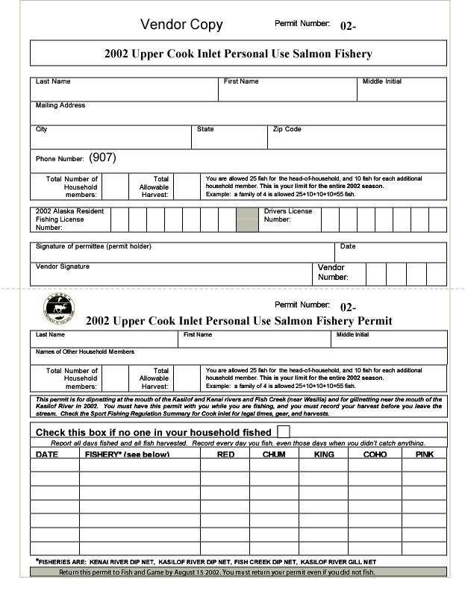
Appendix A1.-Page 2 of 2.
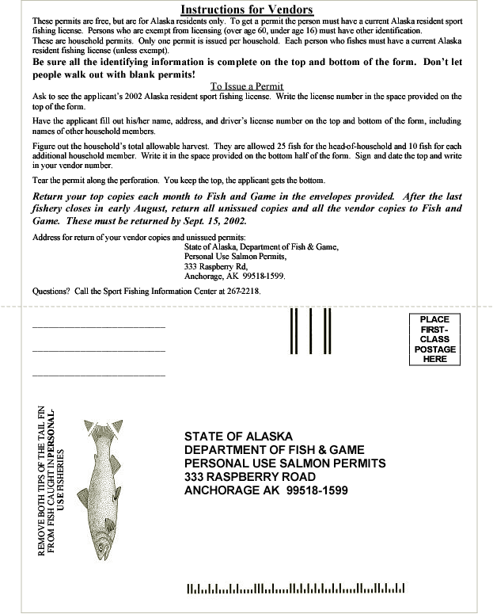

APPENDIX B. Cumulative harvest timing for Upper Cook Inlet personal use fisheries, 1996-2003
Appendix B1.-Cumulative harvest timing for the Fish Creek 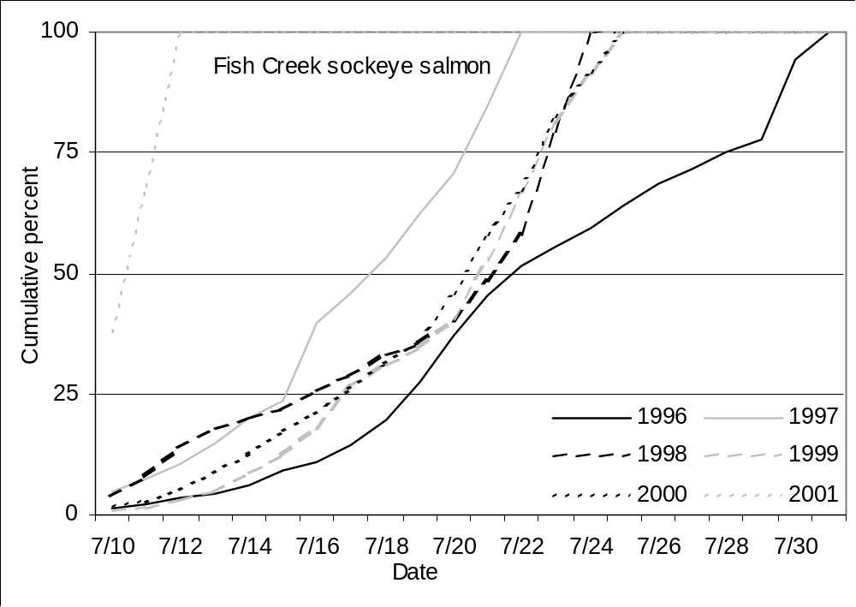personal use dip net fishery 1996-2001.
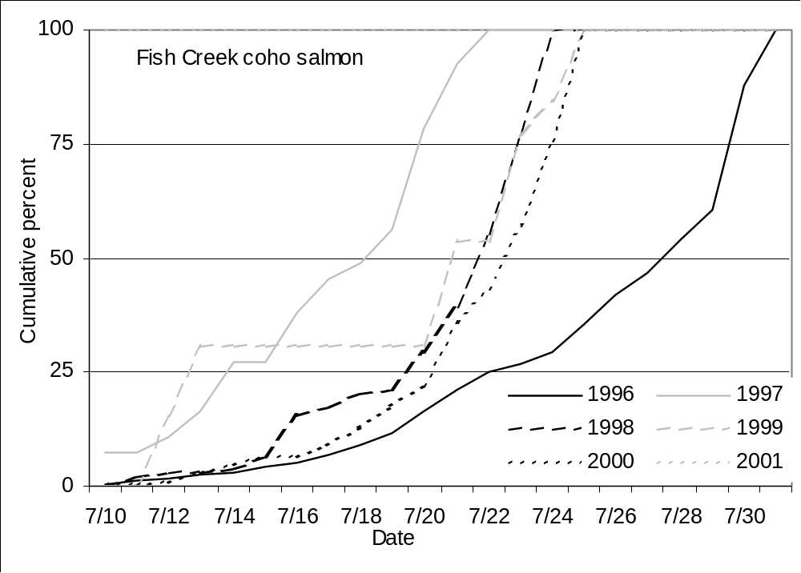
ª Total harvests by species and year are shown in Table 3.
Appendix B2.-Cumulative harvest timing for the Kasilof personal use dip net fishery 1996-2003.
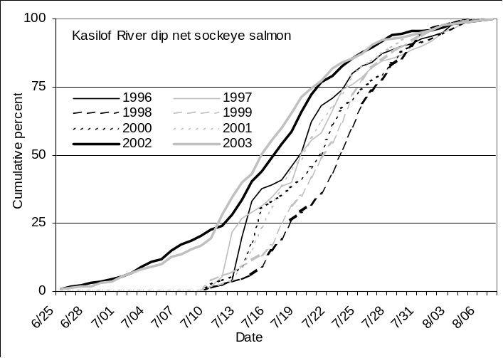
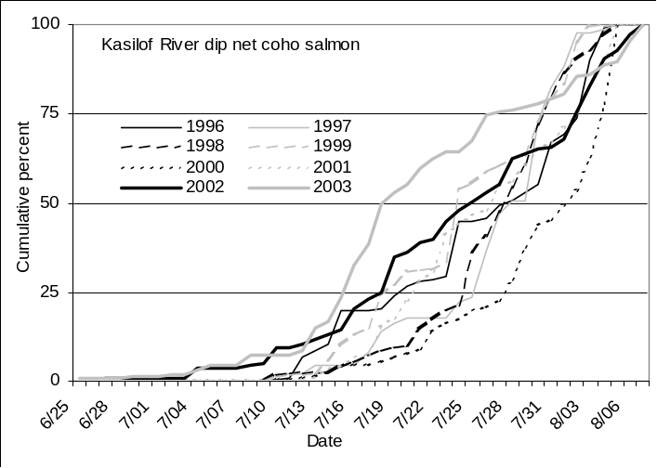
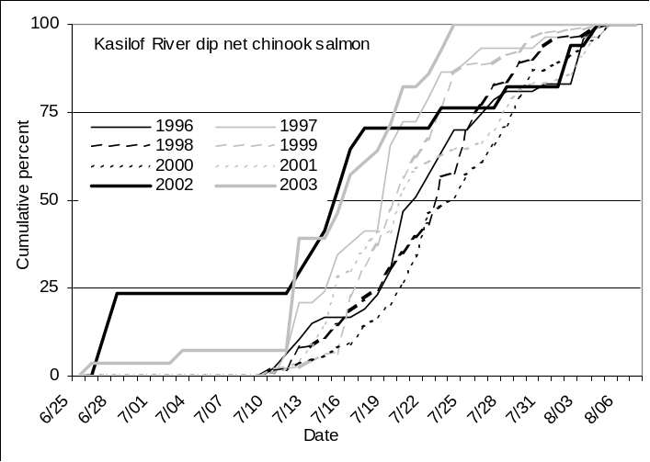
ª Total harvests by species and year are shown in Table 3.
Appendix B3.–Cumulative harvest timing for the Kasilof River personal use gillnet fishery 1996-2003.
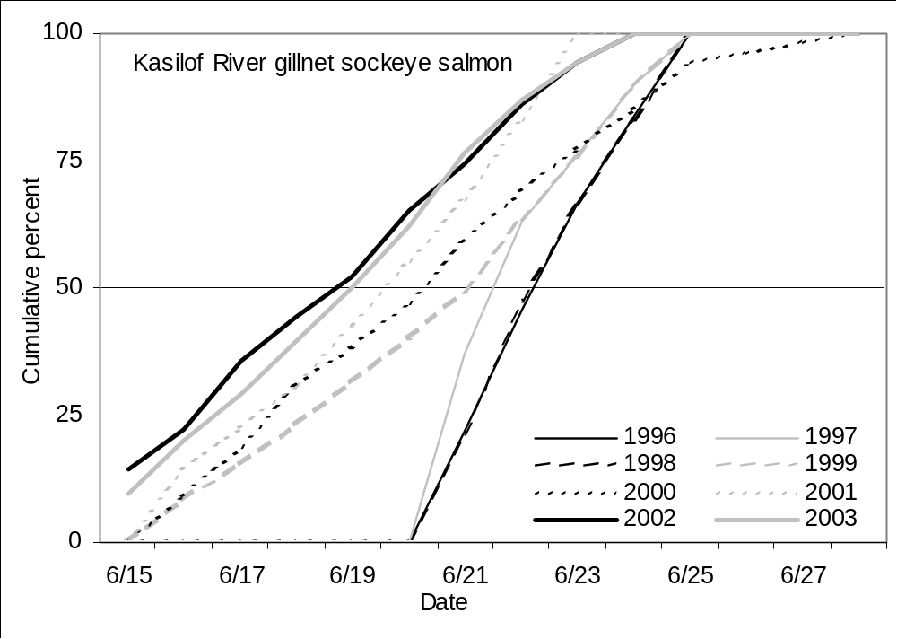
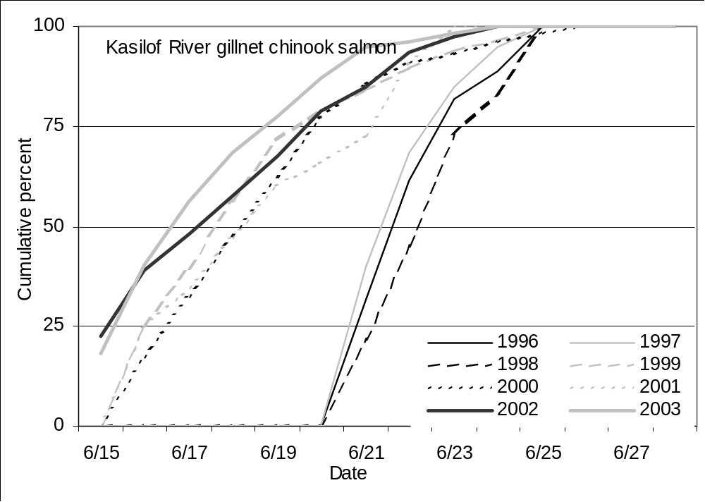ª Total harvests by species and year are shown in Table 3.
Appendix B4.–Cumulative harvest timing for the Kenai River personal use dip net fishery 1996-2003.
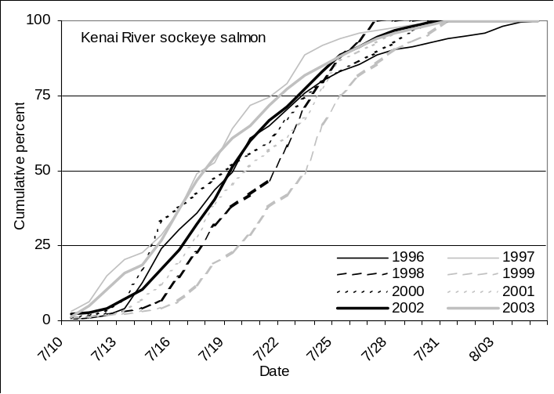
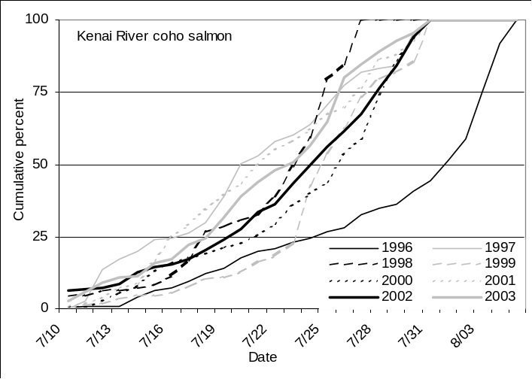
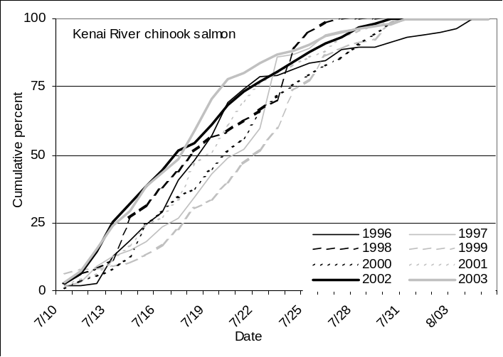
ª Total harvests by species and year are shown in Table 3.

